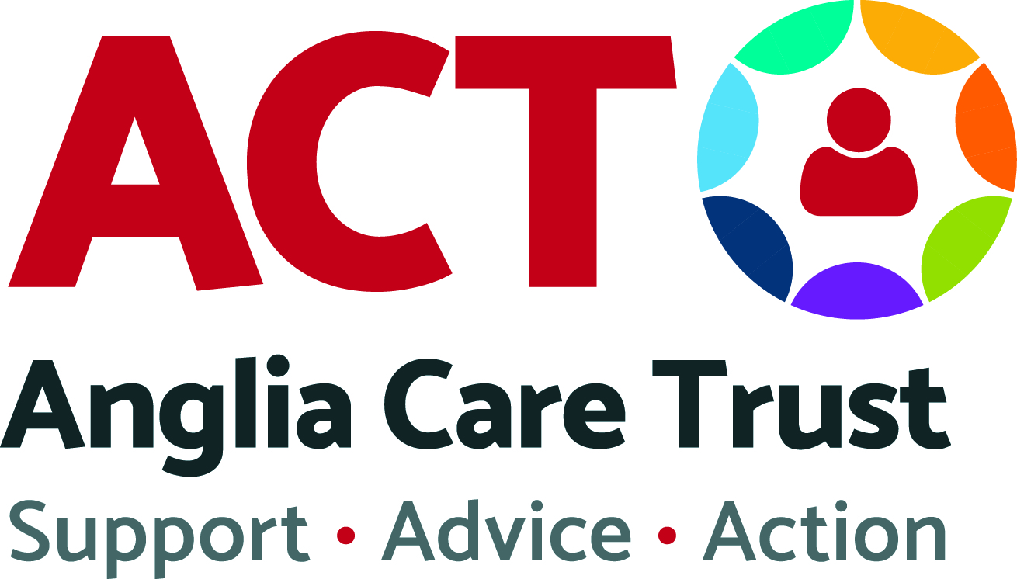
Money Advice

Referral Form & Financial Health Check
Referring Agency Details
Referring Agency
Name of Contact
Position
Telephone Number
Email

Service User Details
Title |  | Marital Status
First Name(s)
Last Name
National Insurance Number |  | Date of Birth
Address (including postcode)
Home Number |  | Work Number
Mobile Number |  | Is this safe to call? | Yes | No

Household Details
Partner name
Dependents name(s) and date(s) of birth
Non-dependents name(s) and date(s) of birth
Do you have recourse to public funds? (please tick )
Yes |  | No |  | Don’t Know

Housing Status (please tick )
Homeowner |  | Shared/HMO |  | Hostel
Sofa Surfing |  | Refuge |  | Street Homeless
Temporary Accommodation |  | Rented – Private |  | Rented – Local Authority
Rented – Housing Association |  | Name of Housing Provider-

Are you at risk of eviction? (If yes do you have…)
Notice seeking possession (NSP) |  | Possession order
Warrant for eviction

Health and Social Circumstances
Alcohol Misuse |  | Offending History |  | Child Protection Issues
Physical Disability |  | Domestic Violence |  | Risk of self-harm
Learning Disability |  | Sexual Offences |  | Long Term Illness
Substance Misuse |  | Mental Health Difficulties |  | Violent Behaviour
Other (please specify)

Are you a victim of Domestic Abuse?
This includes current or past victims of physical, sexual, emotional or financial abuse; and victims of female genital mutilation or honour based violence. | Yes | No
Are the perpetrator details known? Please provide details (e.g. Name, Address, etc.) | Yes | No
Has the abuse been reported to the police? | Yes | No
If yes, was this reported to the police before receiving support or during? | Before | During

Are you a victim of Financial Abuse? (Has a partner, relative, friend or associate ever…)
Stopped or controlled access to your wages, benefits or savings? | Yes | No
Forced you to take out credit or incurred debt on their behalf? | Yes | No
Forced you to commit fraud? | Yes | No
Transferred financial liability into your name against your wishes? | Yes | No
Refused to contribute to household costs or withheld child maintenance? | Yes | No
Interfered with your employment or education? | Yes | No
Do you have access to a bank account in your name? | Yes | No
Do you have access to important household documents? i.e. tenancy agreements, bank statements, passports | Yes | No
Do you open your own post? | Yes | No

Income and employment
Employed: Full-Time |  | Employed: Part-Time |  |  | Self-Employed
Retired |  | Unemployed |  |  | Pension
Child maintenance |  | Tax Credits |  |  | Pension Credits
PIP / DLA / AA |  | ESA / JSA / IS |  |  | Child Benefit
Carer |  | Universal Credit |  |  | No Income
Other (please specify)
Do you have sufficient income to live off? |  |  | Yes |  |  | No
Do you need help to apply for benefits? |  |  | Yes |  |  | No
Do you need help to maximize your income? |  |  | Yes |  |  | No

Debts
Fines (court) |  | Amount:
Housing arrears |  | Amount:
Council tax arrears |  | Amount:
Gas arrears |  | Amount:
Electric arrears |  | Amount:
Water arrears |  | Amount:
Benefits overpayment |  | Amount:
Other debts |  | Amount:
Are you at risk of bailiff action? |  | Yes | No
Are you up to date with your utility bills? |  | Yes | No

Summary of difficulties and assistance required (including details of any guidance already provided)
Confidentiality - to be completed by the Service User prior to referral

I understand that the Referring Agency and Anglia Care Trust will exchange such information as necessary for the purpose of this referral.

By signing below, I am giving my consent for you to collect and store my data as outlined in the General Privacy Notice available at https://angliacaretrust.org.uk/wp-content/uploads/2018/05/General-Privacy-Notice.pdf

I am aware that I can withdraw or change my consent at any time by contacting the Business Support Team on the details below.

Signed - Service User:
Date:
Send completed forms to:
Anglia Care Trust, 8 The Square, Martlesham Heath, Ipswich, Suffolk, IP5 3SL
Tel: 01473 622 888 Fax: 01473 618 660 Email: admin@angliacaretrust.org.uk

Equality and Diversity
Anglia Care Trust is committed to Equality and Diversity. In order to ensure the effectiveness of this policy, all service users are requested to provide the following information. This monitoring form is strictly confidential and this information is used to ensure that access to this service is open and available to all members of the community.
1. Gender
Male |  | Transgender
Female |  | Prefer not to say
2. Ethnic background
White
English/Scottish/Welsh/ Northern Ireland/UK |  | Gypsy or Irish Traveler
Irish |  | Any other white background
Mixed ethnic background
Mixed ethnic background
Asian/Asian British
Indian |  | Bangladeshi
Pakistani |  | Chinese
Any other Asian background
Black/Black British
African |  | Caribbean
Any other black background
Other ethnic group
Arab |  | Other ethnic group
Prefer not to say
3. Disability
Disabled |  | Prefer not to say
Not disabled
4. Age
0-24 years |  | 65+ years
25-64 years |  | Prefer not to say
5. Sexual orientation
Heterosexual |  | Gay/Lesbian
Bisexual |  | Prefer not to say
6. Religion or belief
Christian |  | Muslim
Buddhist |  | Sikh
Hindu |  | Other religion
Jewish |  | Prefer not to say
No religion
7. How did you find out about our service
Local Newspaper |  | Radio
ACT Website |  | Word of mouth
Other (please specify below) |  | Prefer not to say

